📘 PROJECT REPORT
Real-Time Hand Gesture Recognition Using Machine Learning

CHAPTER 1: INTRODUCTION
1.1 Background
Human–Computer Interaction (HCI) is a rapidly evolving field that focuses on improving the way humans interact with machines. Traditional input devices such as keyboards and mice are limited in providing natural and intuitive interaction. Hand gesture recognition offers a contactless and intuitive solution by allowing users to communicate with systems through natural hand movements.
With the advancement of computer vision libraries and machine learning algorithms, it is now possible to detect hand landmarks accurately in real time using standard cameras. Machine learning models can then classify gestures based on extracted features, enabling applications in assistive technology, virtual reality, robotics, and smart systems.

1.2 Problem Statement
Despite advancements, many gesture recognition systems struggle with issues such as user dependency, scale variation, orientation changes, and real-time performance constraints.
Problem Statement:
To design and implement a machine learning–based real-time hand gesture recognition system that can accurately detect and classify multiple hand gestures using live webcam input while maintaining good generalization across users.

1.3 Objectives
The objectives of this project are:
- To collect hand gesture data from multiple participants using a webcam
- To extract meaningful hand landmark–based features
- To preprocess and normalize the data for invariance
- To train a supervised machine learning model for gesture classification
- To evaluate the model using standard ML metrics
- To deploy the trained model for real-time gesture prediction

1.4 Scope of the Project
- Recognition of 25 static hand gestures
- Support for single-hand and two-hand gestures
- Multi-user (participant-independent) model
- Real-time prediction using a webcam

CHAPTER 2: LITERATURE REVIEW
Previous studies in hand gesture recognition primarily use either sensor-based or vision-based approaches. Vision-based methods are preferred due to their non-intrusive nature and ease of deployment.
Recent research highlights:
- The effectiveness of hand landmark detection over raw image-based approaches
- The importance of feature normalization to handle scale and translation variance
- The suitability of neural networks for non-linear gesture classification tasks
Based on these findings, this project adopts a landmark-based feature extraction approach combined with a Multi-Layer Perceptron (MLP) classifier.

CHAPTER 3: SYSTEM ARCHITECTURE
3.1 Overall Workflow

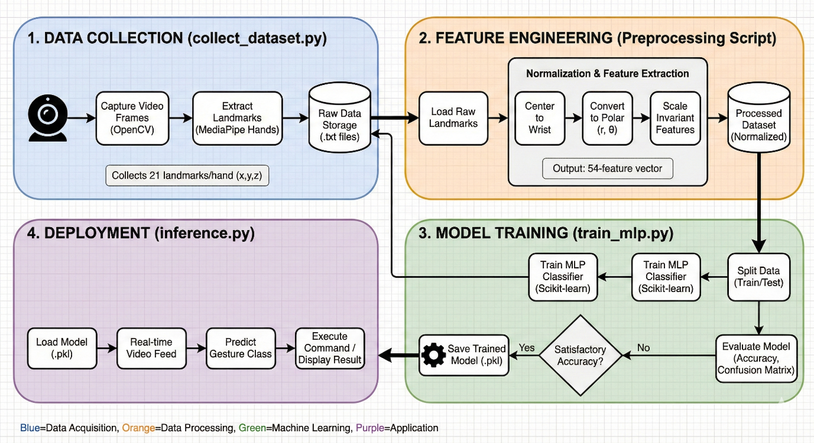
System Flow:
- Webcam video capture
- Hand detection and landmark extraction
- Feature extraction
- Feature normalization
- Model training / prediction
- Gesture output display

3.2 Tools and Technologies
Component | Technology
Programming Language | Python
Computer Vision | OpenCV
Hand Detection | MediaPipe
Machine Learning | Scikit-learn
Model | Multi-Layer Perceptron (MLP)
Visualization | Matplotlib
Deployment | Real-time webcam inference

CHAPTER 4: DATA COLLECTION (ML PHASE 1)
4.1 Data Acquisition
Hand gesture data was collected using a standard webcam. Multiple participants performed predefined gestures in front of the camera. Each gesture was recorded multiple times to capture variations in hand orientation and positioning.

4.2 Feature Extraction
For each detected hand, 48 raw features were extracted:
- Hand orientation (front/back)
- 21 landmark x-coordinates
- 21 landmark y-coordinates
- 5 finger state indicators (open/closed)
For two hands:
48 (Left Hand) + 48 (Right Hand) = 96 raw features

4.3 Dataset Organization
dataset/
└── participant_i/
└── gesture_1 ... gesture_25/
Each file represents one gesture sample.

CHAPTER 5: FEATURE ENGINEERING & PREPROCESSING (ML PHASE 2)
5.1 Need for Preprocessing
Raw landmark coordinates vary due to:
- Hand size differences
- Distance from camera
- Position on screen
Without preprocessing, the model would not generalize well.

5.2 Normalization Process
The following steps were applied:
- Translate landmarks so the wrist becomes the origin
- Convert (x, y) coordinates into radial distances
- Normalize distances using maximum radius
- Preserve finger states and orientation
This process reduced:
96 raw features → 54 normalized features

5.3 Benefits
- Scale invariance
- Translation invariance
- Reduced noise
- Improved model generalization

CHAPTER 6: DATA PREPARATION (ML PHASE 3)
- Each gesture folder corresponds to one class label
- Gesture IDs (1–25) are used as target labels
- Data from multiple participants is combined
This enables participant-independent supervised learning.

CHAPTER 7: MODEL SELECTION (ML PHASE 4)
7.1 Chosen Model: Multi-Layer Perceptron (MLP)
The MLP classifier was chosen because:
- It handles non-linear relationships effectively
- It works well with fixed-length numerical features
- It is efficient for medium-sized datasets

7.2 Model Architecture
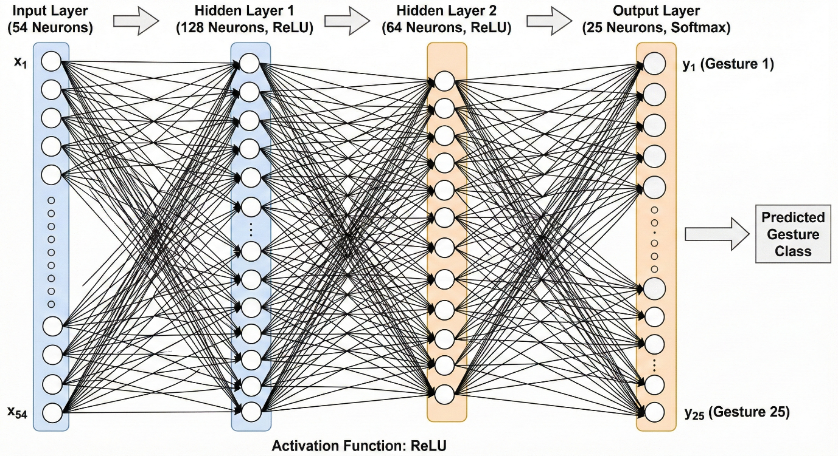
Layer | Description
Input Layer | 54 neurons
Hidden Layer 1 | 128 neurons (ReLU)
Hidden Layer 2 | 64 neurons (ReLU)
Output Layer | 25 gesture classes
Optimizer | Adam
Regularization | L2
Early Stopping | Enabled

CHAPTER 8: MODEL TRAINING (ML PHASE 5)
8.1 Training Strategy
- Dataset split into 80% training and 20% testing
- Stratified split to maintain class balance
- Early stopping used to prevent overfitting

CHAPTER 9: MODEL EVALUATION (ML PHASE 6)
9.1 Accuracy Results
- Training Accuracy: 84.40%
- Testing Accuracy: 83.40%
The close gap between training and testing accuracy indicates good generalization.

9.2 Precision, Recall, and F1-Score
Macro Average:
- Precision: 0.8591
- Recall: 0.8340
- F1-score: 0.8317
Micro Average:
- Precision: 0.8340
- Recall: 0.8340
- F1-score: 0.8340
Weighted Average:
- Precision: 0.8591
- Recall: 0.8340
- F1-score: 0.8317
Interpretation:
- High macro scores indicate balanced performance across gesture classes
- Micro averages reflect overall classification accuracy
- Weighted averages confirm robustness despite class variations

9.3 Confusion Matrix Analysis
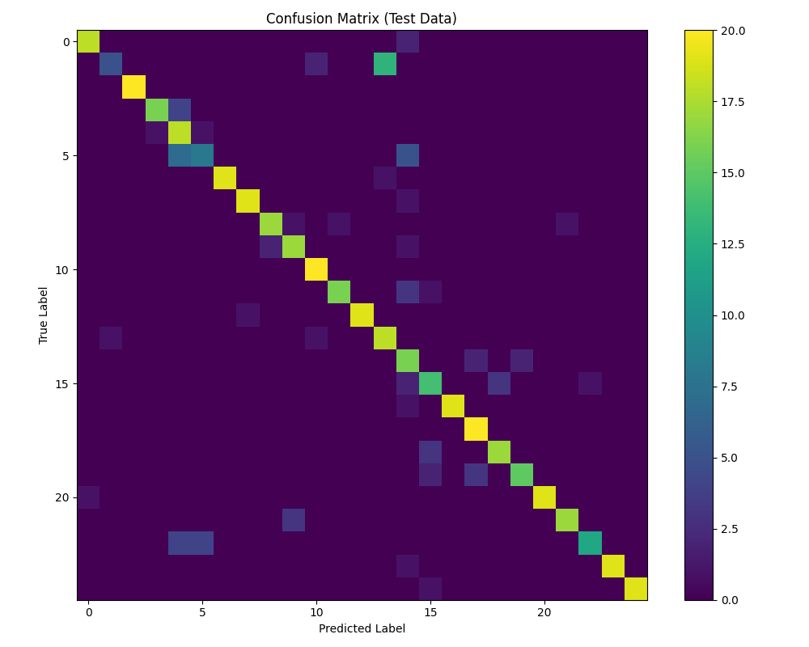

The confusion matrix shows a strong diagonal pattern, indicating correct classification for most gestures. Minor misclassifications occur between visually similar gestures, which is expected in vision-based systems.

CHAPTER 10: REAL-TIME DEPLOYMENT (ML PHASE 7)
10.1 Deployment Process
- Webcam captures live video frames
- Hand landmarks extracted in real time
- Features normalized on-the-fly
- Trained MLP model predicts gesture instantly
10.2 Output
- Gesture name displayed on screen
- Low latency real-time performance achieved

CHAPTER 11: RESULTS
- Successful recognition of 25 gestures
- Real-time operation achieved
- Stable performance across multiple users
- Good balance between accuracy and generalization

CHAPTER 12: CONCLUSION
This project successfully demonstrates a machine learning–based real-time hand gesture recognition system following the complete ML lifecycle. By combining landmark-based feature extraction with a neural network classifier, the system achieves reliable gesture classification with good generalization across participants.

CHAPTER 13: FUTURE SCOPE
- Increase number of participants and gestures
- Support dynamic gestures using LSTM models
- Improve robustness under varying lighting
- Deploy on mobile or embedded platforms
- Integrate gesture-based control applications

